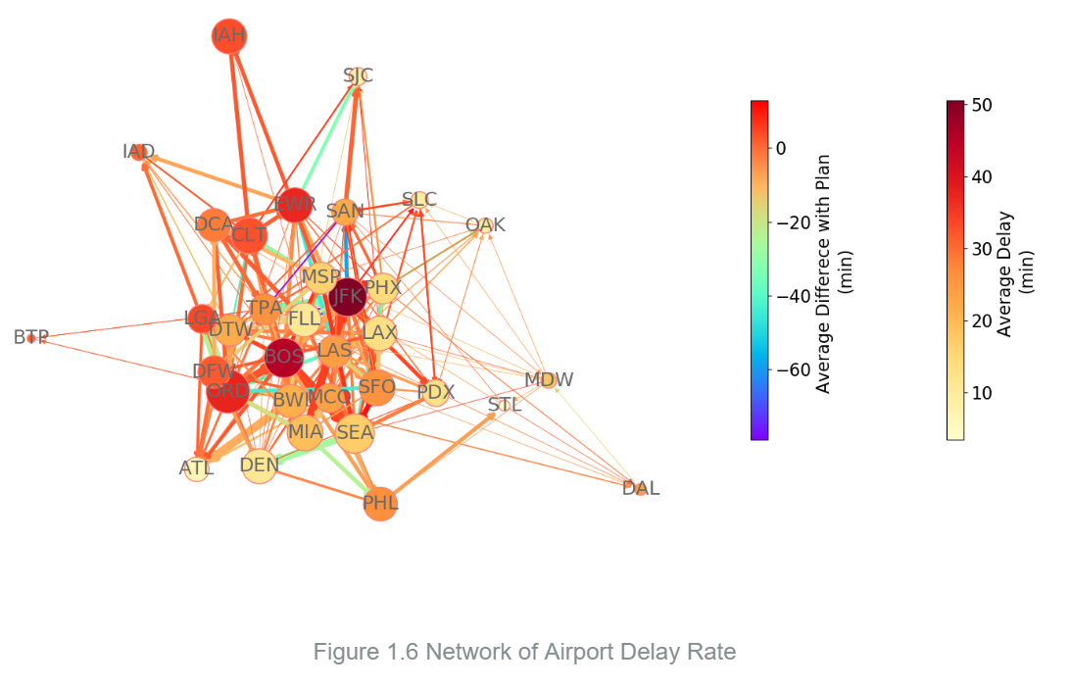

In the network shown in Fig. 1.6 above, the nodes are airports and edges are the airlines between airports. Size of a node represents the number of flights (inbound and outbound) of this airport, and color of a node represents the average delay time in minutes of this airport. Similarly, the width of an edge represents the number of flights of this airline, and color of an edges represents the average flight time difference with original flight plan. In Fig. 1.6, nodes with degrees lower than 3 are excluded for a clearer view of the central cluster. We observe that the major US airports are clustered together, and several major airports (ex. BOS at Boston and JFK at New York) have severe long delay are the significant hubs in the network. If other airports are linked with a hub airport which has severe delay problem, then average delay times of these airports are usually longer.

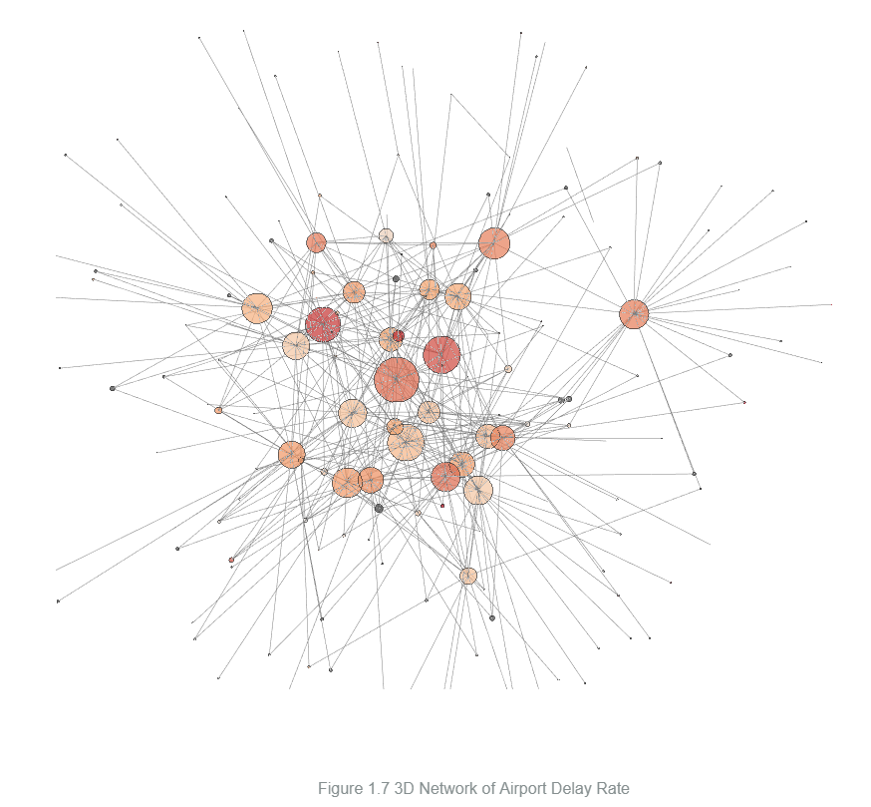

Fig. 1.7 is a 3-D interactive network of our dataset. Same as the 2-D Fig. 1.6 above, the nodes are airports and edges are the airlines between airports. Size of a node represents the number of flights (inbound and outbound) of this airport, and color of a node represents the average delay time in minutes of this airport. Different from Fig. 1.6, we include all the nodes and edges in Fig. 1.7. We observe that the airports network shares some same characteristics with scale-free network. Firstly, in a scale-free network, most nodes in the network only have low degrees (lower than 5) and few nodes have extremely high degree. As for airports network, most airports are small commuter airports which only have several airlines linked to adjacent hub airports. The major airports are the hub nodes in the airports network. Secondly, hubs are both a strength and a weakness of scale-free networks. For airports network, even a large portion delay between hubs and other nodes may not affect the whole network. However, if several hubs have severe delay at the same time, the whole network will be severely impacted. For example, the 2010 eruptions of Eyjafjallajökull at Iceland paralyzed all hub airports in Europe, and thus impact the airports network in the whole world.